Make a simple endpoint
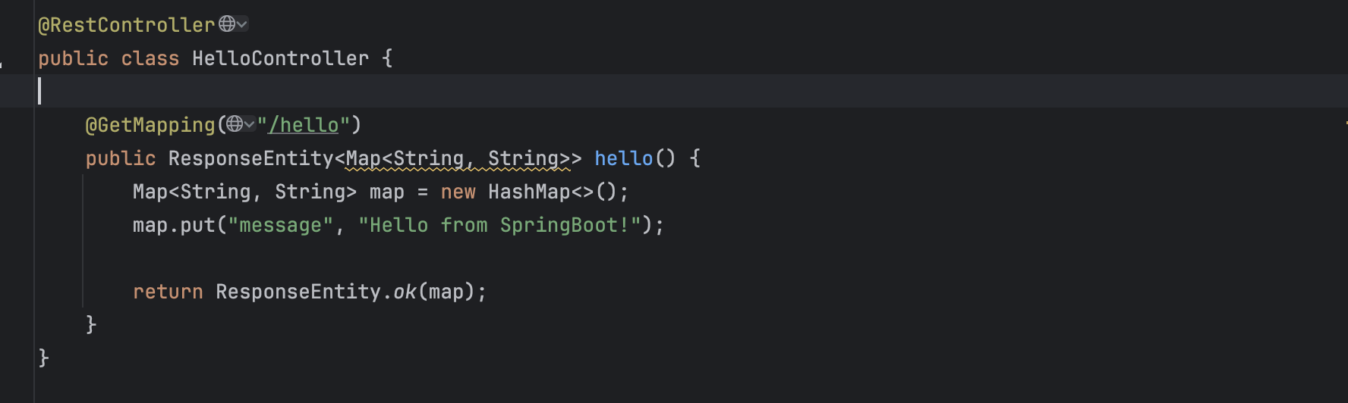
Set up https in application.properties. The url of the endpoint will be https://localhost:8443/hello
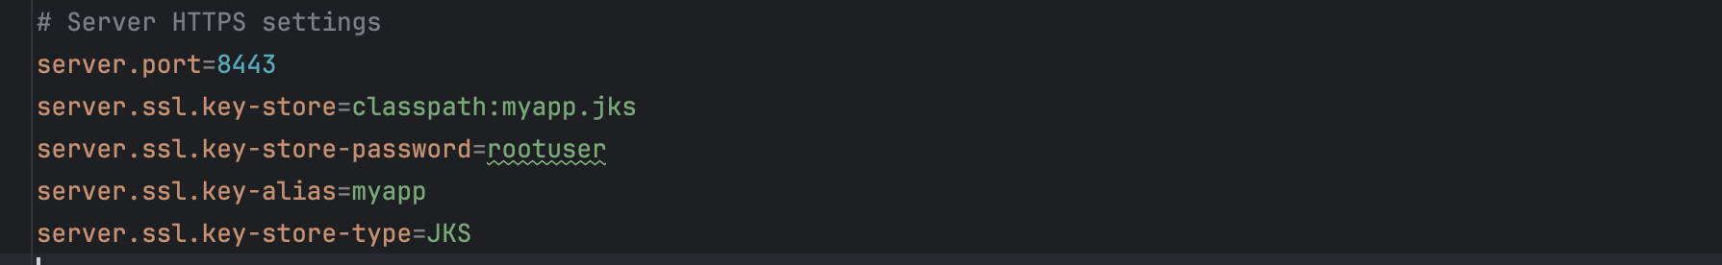

Turn on SSL certificate verification on POSTMAN
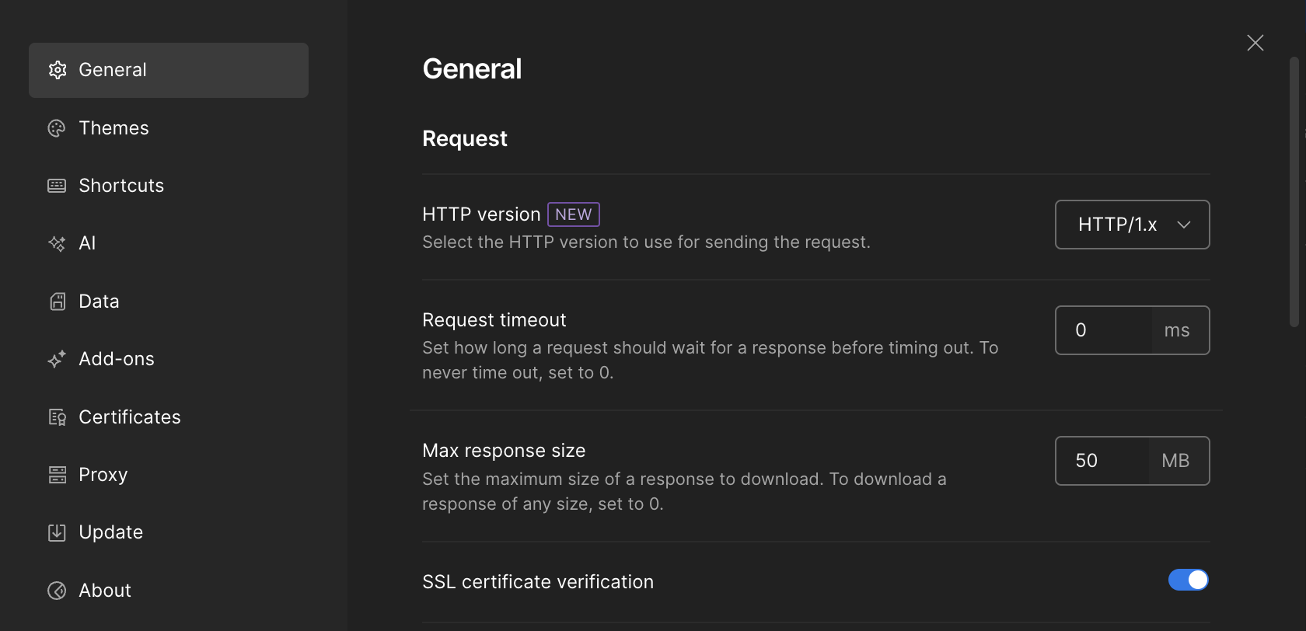

Now, visiting the endpoint https://localhost:8443/hello will give an error:
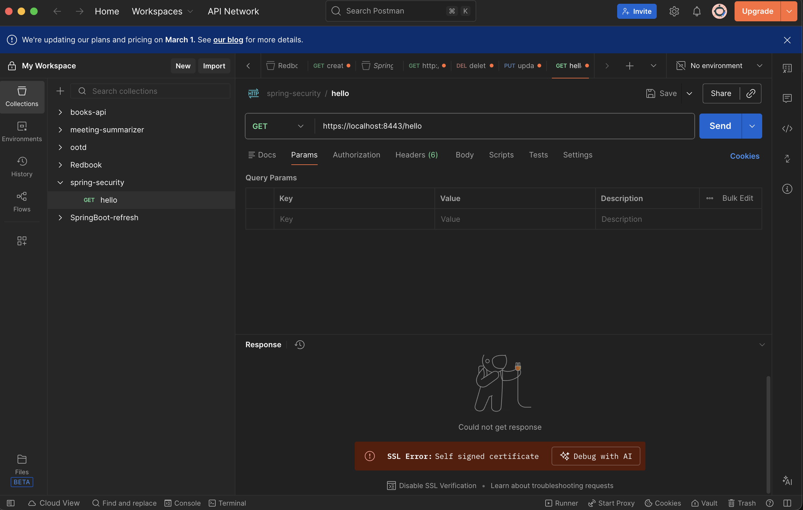

Run the following commands in the project folder to generate self-sign SSL/TLS:
keytool -genkeypair \
-alias myapp \
-keyalg RSA \
-keysize 2048 \
-storetype JKS \
-keystore src/main/resources/myapp.jks \
-validity 3650
First name and last name should be set to “localhost”, the rest is optional
This will make a myapp.jks file.
Move that file to “/main/resources” folder

Export .crt file with this command
keytool -export -alias myapp \
-keystore src/main/resources/myapp.jks \
-rfc -file src/main/resources/myapp.crt
The -rfc flag ensures the file starts with -----BEGIN CERTIFICATE-----, which Postman prefers.
Now import the .crt file in postman.
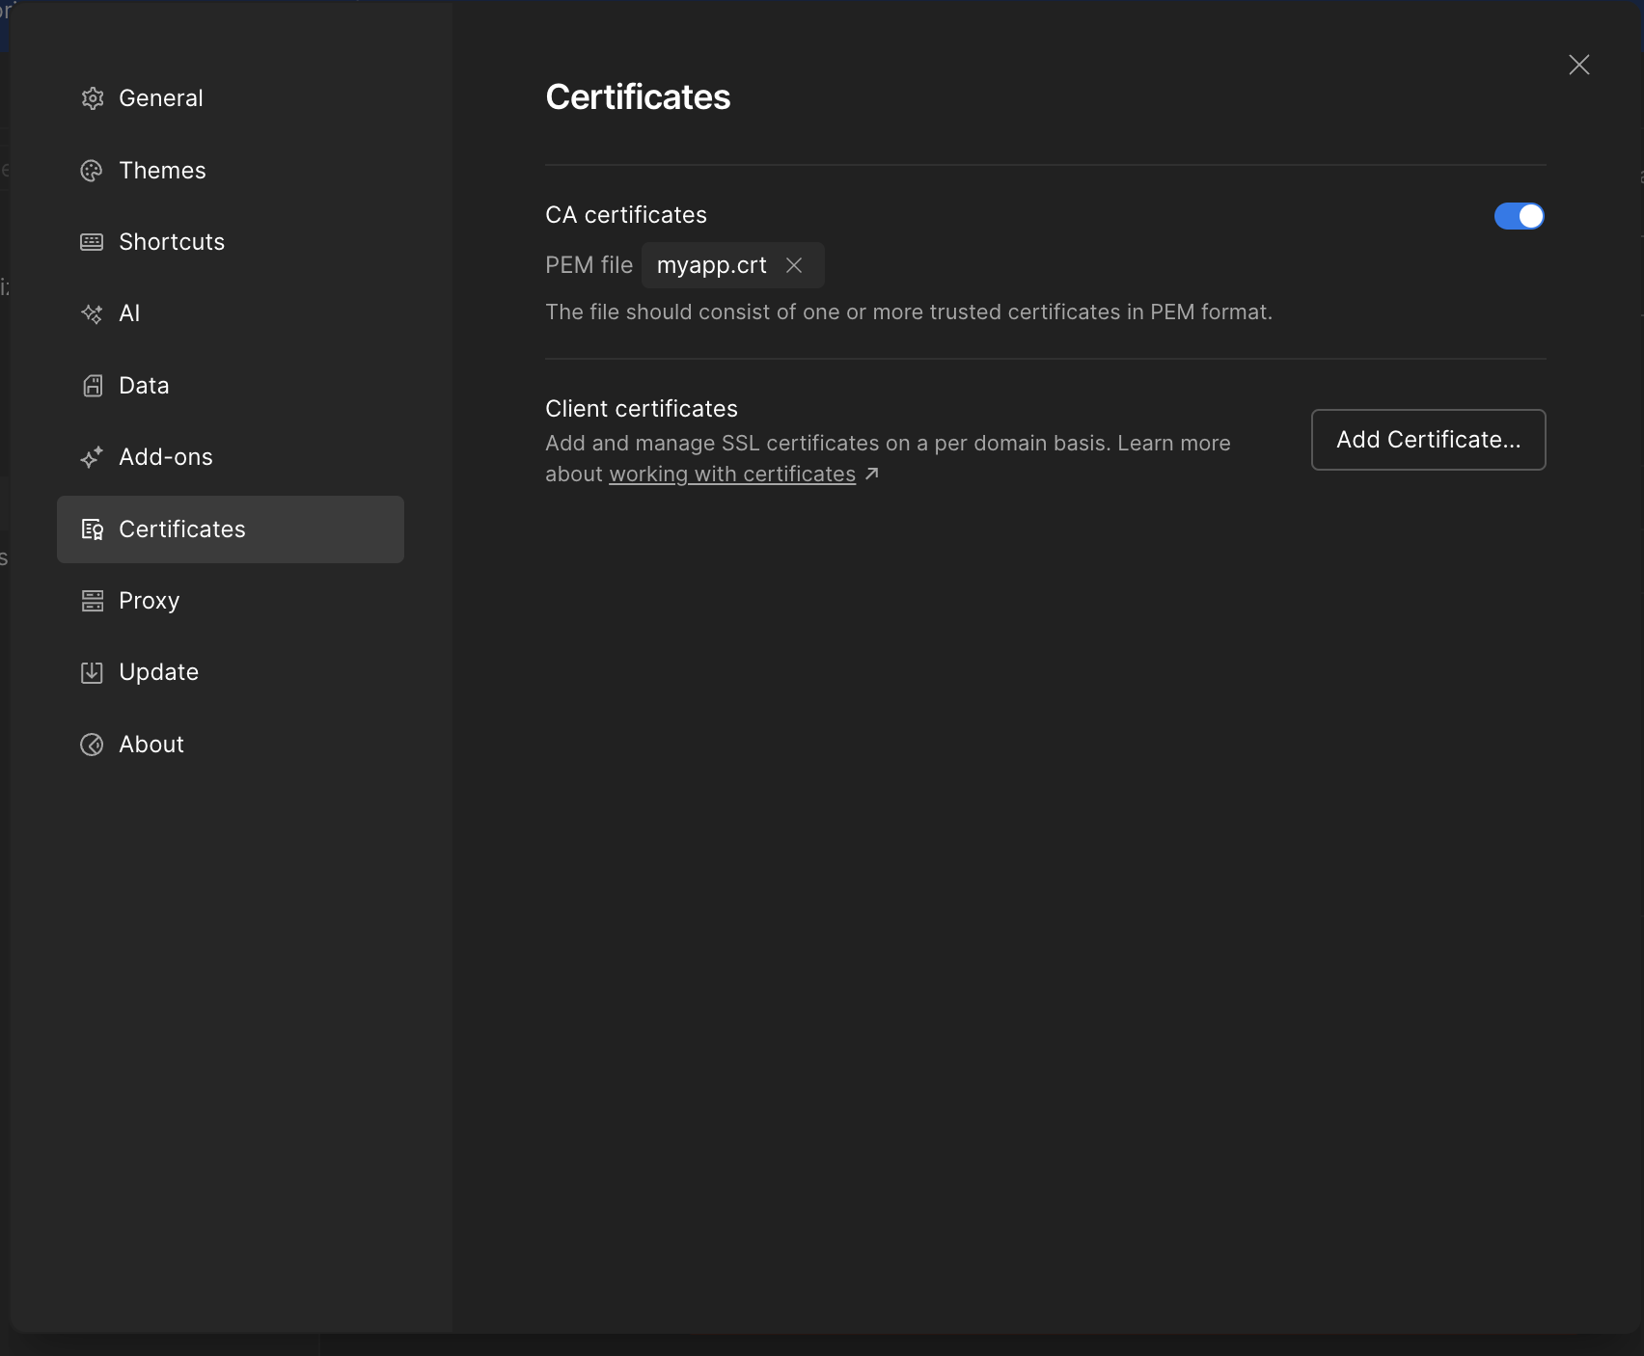

It works!
